For immediate release
CASTELLE’s 2019 Introduction Rollout Continues with the Avenue Collection
Summary: Luxury outdoor living with a nod to modernism is unveiled by Castelle with the Avenue Collection for the 2019 season. A linear design with three-quarter scale profile is featured in this contemporary collection.
Ft. Lauderdale, Fla.- Castelle, the award-winning designer and manufacturer of luxury casual furniture, will debut for 2019 the AVENUE Collection, a unique design with a nod to structural modernism. Expressing an uncluttered yet architectural form, the Avenue Collection by Castelle features linear supports and encircling curves.

The slender three-quarters proportions of the AVENUE Collection are purposefully designed to create seating suitable for outdoor space of any size. The collection boasts a select combination of deep seating, chat pieces and coordinating tables.

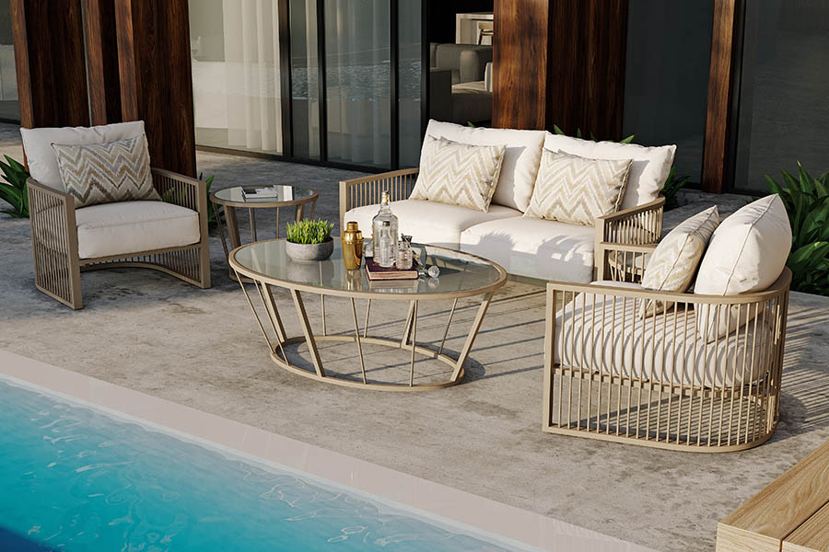
“The 2019 introductory season already is off to an exciting start with our recently introduced collaborations,” said Mark Stephens, president, CASTELLE. “With the addition of the AVENUE Collection, our retailers are again reminded of Castelle’s commitment to providing variety in casual furniture designs with each season.”

Slender vertical lines and bordering organic curves handcrafted of extruded aluminum are featured on all pieces in this collection. Tailored seat cushions and throw-style back and kidney pillows add to the overall comfort factor. The full complement of Castelle’s fabrics and finishes is available on the Avenue Collection.

For more information about Castelle and luxury casual furniture, visit www.castelleluxury.com.
# # #
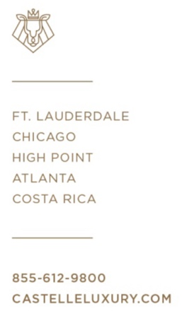
High Resolution images available. Contact: lrudd@pridefamilybrands.com
Pictured: Avenue Collection deep seating set

About CASTELLE®.
For over 40 years, CASTELLE has distinguished itself in the manufacturing of award-winning luxury casual furniture. Innovation, state of the art manufacturing, and superior quality products are the trademark of CASTELLE and the reason CASTELLE is recognized as a leader in the casual furniture industry. CASTELLE has been the recipient of multiple Manufacturing Leadership awards for the Cast Aluminum category.

