CASTELLE Announces Launch of Latest Collaboration - Biltmore® by Castelle

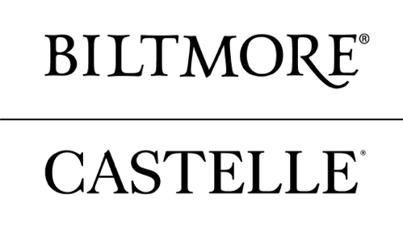
Ft. Lauderdale, FL – March 8, 2018 - Castelle announces the upcoming launch of its latest collaboration of distinctive outdoor furnishings with the creation of Biltmore® by Castelle. Featuring details of America’s Largest Home®, this collaboration will be unveiled within the Castelle High Point showroom (IHFC-Main 101) during the international furniture market. A provider of handcrafted luxury outdoor furnishings for more than 40 years, Castelle is partnering with Biltmore to create an outdoor collection drawn from the classic architectural elements of George Vanderbilt’s endlessly-inspiring estate.
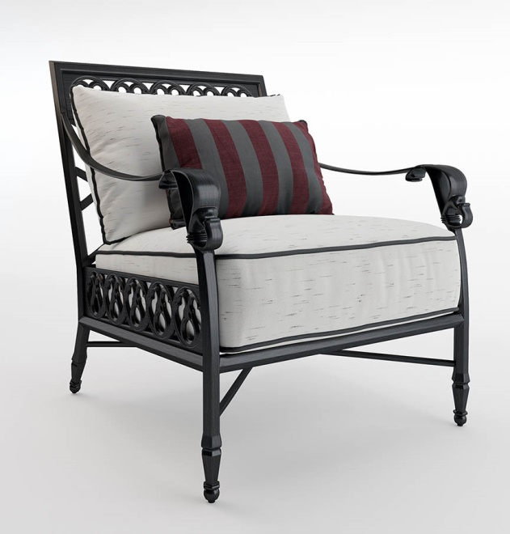

“Creating comfortable and beautiful spaces to enjoy the fresh air of the Blue Ridge Mountains was key in Mr. Vanderbilt’s vision of providing an oasis for his family and friends,” said Tim Rosebrock, vice-president and general manager, Biltmore Licensed Consumer Products. “He selected products of highest quality and classic design, and the artistic details and craftsmanship of the Biltmore Collection by Castelle reflect this appreciation for luxury.”

The first collection to debut within Biltmore by Castelle will be the Estate Collection that is handcrafted of cast and extruded aluminum. Each dining or deep seating piece features elements inspired by architectural design and classic lattice-work details found on the grand Loggia and Library Terrace of Biltmore House.

“From the moment this collaboration was discussed, the similarities that exist between our companies in our mutual pursuit of elegant experiences and a shared reverence of outdoor spaces became clear to each member of our design and marketing teams,” said Derek Ritzel, president and CEO, Castelle. “The sense of artistry and craftsmanship that also is a part of not only this unbelievable home; but the estate’s surrounding lands and gardens mirrors that sense associated with the Castelle brand. The partnering was a natural fit and one we are proud to be introducing.”

In creating Biltmore, George Vanderbilt envisioned a private, peaceful retreat where family and friends could relax and enjoy all the comforts of home—including the refreshing beauty of the natural world. From the breezy

Loggia with sweeping views of the mountains to inviting terraces that beckoned guests to explore the estate’s grand gardens and woodland trails, no detail of outdoor living was overlooked.

“Castelle’s design team made multiple trips to Biltmore, diving deep into our archives and storage rooms for product inspiration,” said Donnette Miller, director of licensing, Biltmore Licensed Consumer Products. “It was a
pleasure to work with such a talented team. Watching them weave inspiration from the gardens and
architectural elements of the house into collections that are relevant to today’s décor while still honoring timeless design was inspiring and affirmed for us that Castelle is an excellent partner for our outdoor living furniture.”

The launch will kick off with an elegant brunch within the Castelle showroom from 11:00 am to 2:00 pm on Sunday, April 15th. “The Art of Entertaining” will include hors d'oeuvres and Biltmore’s finest wines. Music will be provided by a string quartet to entertain all attendees. The brunch is open to market goers.

Like Biltmore, Castelle’s commitment to quality, thoughtful design, and timeless style ensures that their carefully-crafted products are relevant to modern lifestyles, and as beautiful as they are functional in outdoor settings.

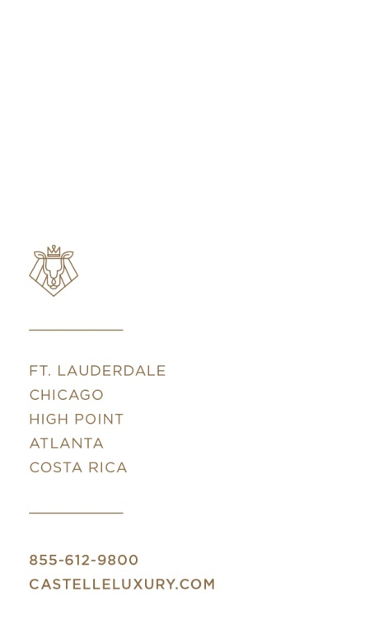
For more information about CASTELLE and their line of casual furniture visit www.castelleluxury.com.
# # #

Pictured: Biltmore® by Castelle co-brand; Biltmore® by Castelle cushioned lounge chair from Estate Collection

About CASTELLE.
For 40 years, CASTELLE has distinguished itself in the manufacturing of award-winning luxury casual furniture. Innovation, state of the art manufacturing, and superior quality products are the trademark of CASTELLE and the reason CASTELLE is recognized as a leader in the casual furniture industry. CASTELLE has been the recipient of multiple Manufacturing Leadership awards for the Cast Aluminum category.

About Biltmore Licensed Products
Biltmore is a highly recognized brand in licensed products, drawing on the historical treasures and inspiration found in George Vanderbilt’s Biltmore House and gardens, located in Asheville, North Carolina. Consumers are able to experience both the classic designs found in the grand collection of art and furnishings of America’s Largest Home®, and the relaxed enjoyment of fine country living. Biltmore partners with industry leading companies in home furnishing, bedding and bath, and gourmet and entertaining. To learn more about Biltmore licensed products, go to www.biltmore.com/products or call 828.225.6791.

