Watermark LivingTM To Highlight Outdoor Living Gallery/”Pop Up” Concept During High Point Market

“Outdoor Made Easy” will continue to be the mantra as Watermark Living returns to High Point Market with its Gallery/”Pop Up” Concept for reaching retailers with casual furnishings, accessories, and proven merchandising plans.

February 5, 2019 – Largo, FL – Watermark LivingTM will present at the upcoming High Point Market its Outdoor Made Easy concept designed to allow full-line furniture retailers to create an Outdoor Living Pop Up style gallery within their stores. Based on a selection of merchandising floor plans, the Watermark Living pop-up program equates to a one-stop resource for casual furnishings merchandise including multiple designs and constructions and coordinating accessories.

"We are excited to offer this trending style of merchandising and marketing to full line furniture retailers or professional designers,” said Chad Harper, national sales manager, Watermark Living. “The Pop-Up configuration or gallery set up allows furniture retailers to expand their market reach with casual furnishings and accessories via intentional purchasing with proven merchandise planning yet without minimums.”

Examples of purchasing packages will be on display during the High Point Preview Market (March 4-5, 2019) and the Spring Market (April 6 – 10, 2019) in the Watermark Living showroom at 205 S. Main Street in High Point. This program is created to include a robust mix of elements and aesthetics at value pricing for retailers looking to enter the outdoor category.

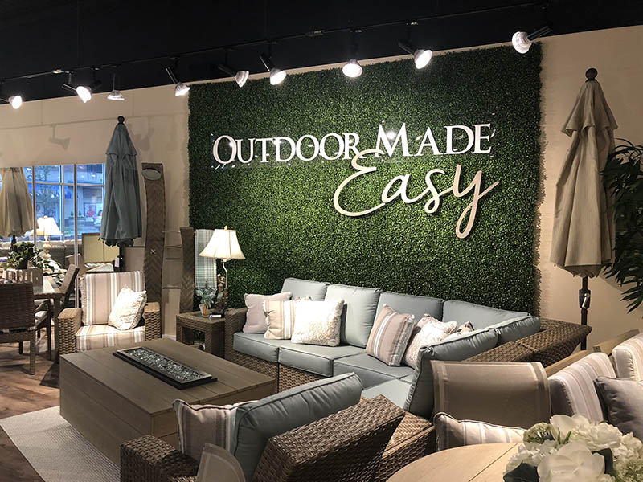
“Our Outdoor Made Easy program is designed to allow casual furnishings and accessories for as little as 500 square feet of floor space,” said Kerrie Jakubcin, Wholesale Division Manager, Watermark Living. “Selections can include as many as seven categories including furnishings of extruded aluminum, cast aluminum, woven, poly-lumber, sling, strap or fire pits. Indoor and outdoor artwork, accessories,

umbrellas and lighting also are popular elements of our plans. The combinations we offer allow for the sought-after mixing and matching on the showroom floor.”

For more information about Watermark LivingTM and its line of quality products, visit www.watermark-living.com.
# # #
About Watermark LivingTM.
Watermark LivingTM is a complete casual resource with more than four decades of dedication in sourcing quality outdoor and rattan products designed and proven to stand the test of time. Created by retailers for retailers, Watermark LivingTM provides fashionable product that is highly customizable with quick turn-around times, from deep seating to casual dining, lighting and accessories. www.watermark-living.com

Editorial Requests:
Contact: Laurie Rudd
lrudd@laurieruddpr.com
RELEASE WORD DOC / IMAGE:
https://www.dropbox.com/sh/bjawzor0s9nt8xe/AADqR50iGmfjqH2XsKW9ZPG5a?dl=0

