Lea Chair - Midj
design Paolo Vernier

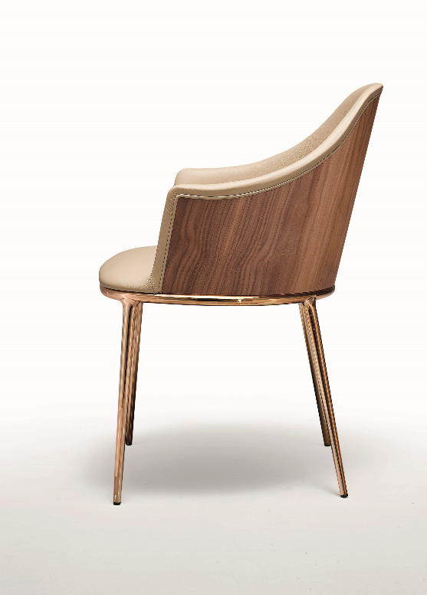

Soft, comfortable, with thin lines, Lea by Midj offers a metal frame which makes it particularly elegant. A metal boundary outlines the seat by giving a sort of play of light which highlights its refined design.
Elegance and versatility characterise LEA which is available in the following versions: chair, armchair, barstool and counterstool. Every version can be upholstered with leather, faux leather and/or fabrics; the wooden outside back is an optional. LEA results to be researched and light in order to satisfy different needs in the residential field.
www.midj.com/
***

Since 1987 Midj has cleverly combined design and the art of modeling the raw material with the creation of custom-made furniture and accessories, to emphasize modernity and elegance in every environment.
From chairs to coat hangers, from tables to armchairs, each product features a concentrate of Made in Italy mastery, which is characterized by a soft and refined design. Thus colorful and versatile ideas come to life, which easily adapt to public and private spaces, guaranteeing a delicate but at the same time hi-tech character.
From the development of the design of the model to the industrial print run, every phase of production is scrupulously followed by master craftsmen of iron, wood, leather and plastics, to combine craftsmanship, creativity and technology into furnishing elements aimed at the highest quality and resistance over time.
To support the philosophy of the Friulian brand, the Integrated Management System certified according to ISO 9001: 2015 and the ISO 14001: 2015 certification, for compliance with environmental regulations, reduction of consumption and pollution. The Code of Ethics is so important: promoting virtuous behavior and processes aimed at combining the correct conduct of the company with the expectations and interests of individual employees.

