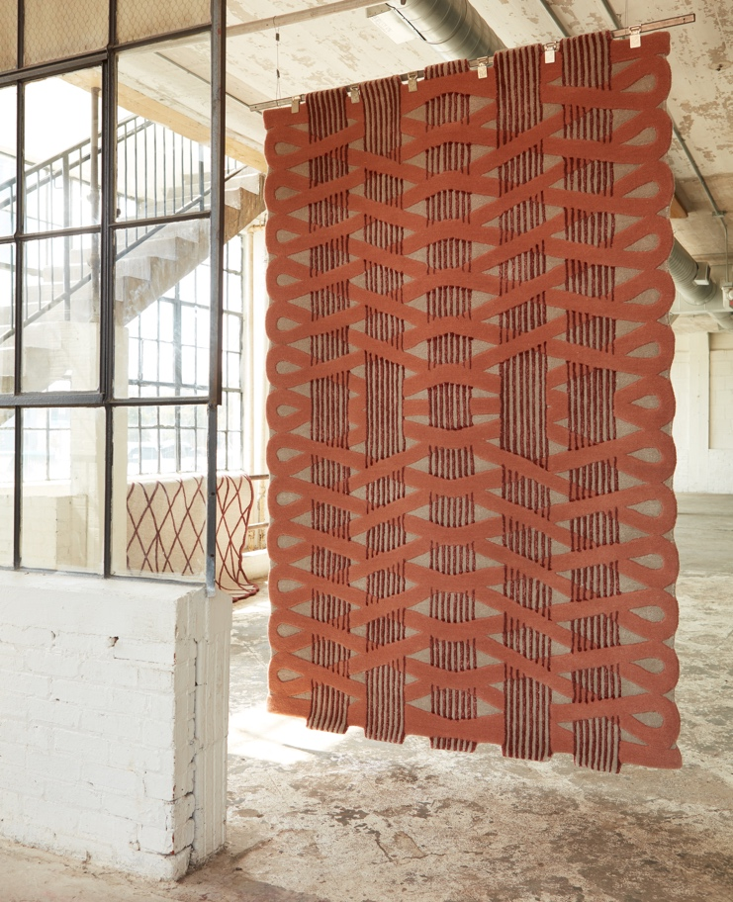

JAIPUR LIVING ROLLS OUT VIBRANT AND ECLECTIC COLLECTION
BY ITALIAN DESIGNER MATTEO CIBIC

FOR IMMEDIATE RELEASE
(ACWORTH, GA – January 12, 2021) Global rug and textile furnishings company Jaipur Living is pleased to introduce Jaipur Wunderkammer, a bold new collection of beautiful handcrafted rugs created by Italian Designer Matteo Cibic.
Cibic has played on the colors, culture and beauty of the historic “Pink City” of Jaipur, Rajasthan in India by mixing geometric and decorative patterns in the many shades of pink, rose, orange and peach that are typical to Jaipur.
“I’ve imbued my creative universe with the peculiar architecture and colors of the city and taken inspiration from ancient paintings and the architectonic sundial,” Cibic said.
The collection is named for Wunderkammer, the cabinets of curiosities that appeared in Europe in the mid-16th century. These room-like cabinets were repositories for all types of wondrous and exotic objects. The Jaipur Wunderkammer collection is handtufted in a wool blend with a cotton backing, and shoppable now on the Jaipur Living website.
JWK01 Jaipur Wunderkammer Royal Patio
The Royal Patio design impresses with its striking architectural lattice details and scalloped shape. Great for modern spaces in a deep wine and light gray colorway.

JWK02 Jaipur Wunderkammer Stair Maze
One could get lost in the labyrinthine pattern of the Stair Maze design with its pink ribbons and wine-colored ticking stripes. Stair Maze is perfect for modern decor.

JWK03 Jaipur Wunderkammer Floral Canvas
The Floral Canvas rug pops with a dot design in a high-low pile and hues of ballet pink, light blue, and bright gold. Floral Canvas is at home in modern decor.

JWK04 Jaipur Wunderkammer Pink Haze
You’ll find yourself entranced with the Pink Haze design’s geometric pattern and rounded rectangle shape. Its tonal gray, pink, and blue hues are right on cue for modern rooms.

JWK05 Jaipur Wunderkammer Pink Building
The striking Pink Building design offers an architectural vista of the city of Jaipur, comprised of geometric shapes and fine-lined details. Pink Building finds its way in global and modern decor.

JWK06 Jaipur Wunderkammer Jaipur Dance
A border of whimsical feet shapes brings a smile to the face in the Jaipur Dance design. Perfect for global and modern rooms in the city of Jaipur’s signature colorway.

JWK07 Jaipur Wunderkammer Pink Perspective
The Pink Perspective design makes a truly artistic statement with its abstract linear pattern. Add rosy, neutral tones contrasting with a deep wine hue for global and modern style.

ABOUT MATTEO CIBIC
Matteo Cibic is an international award-winning trans-media artist, designer, and master in luxury fun, based in Italy. He’s known for his objects with hybrid functions and anthropomorphic and joyful shapes. He works indiscriminately with industrial processes and small artisans, for luxury brands, collectors and hi-tech companies. His works are displayed in museums, institutions and galleries worldwide. Elle Décor named Cibic Young Talent of the Year for 2017.
ABOUT JAIPUR LIVING
With a free-spirited creative aesthetic that celebrates individuality and the everyday, Jaipur Living imbues rugs and textiles for the home with an updated and unmistakable point of view. Inspired by a model that nurtures artisans and indigenous crafts around the globe, the company’s passion for people, product and design stems from a women-centric approach finely attuned to fashion trends and how we want to live today. Boutique-like collections are a cut above and a world apart, blending respect for the handmade with a focus on innovative constructions to create one of the fastest growing home furnishings companies in the U.S.
MEDIA CONTACT:
karen.waygood@jaipurliving.com

SOCIAL:
https://www.instagram.com/jaipurliving/
https://twitter.com/jaipurlivinginc
https://www.pinterest.com/JaipurLiving/
https://www.facebook.com/jaipurliving
https://www.linkedin.com/company/jaipur-living-inc

