For immediate release

CASTELLE to Debut SANTA FE Outdoor Collection For 2019

Ft. Lauderdale, Fla.- Castelle, award-winning casual furnishings manufacturer announces the introduction of its artisan inspired SANTA FE Collection for the 2019 outdoor season. This traditional collection features an oversized profile and plush cushioning. With romantic flair and distinct design styling, the Castelle SANTA FE Collection is crafted to provide a comfort-filled outdoor statement.

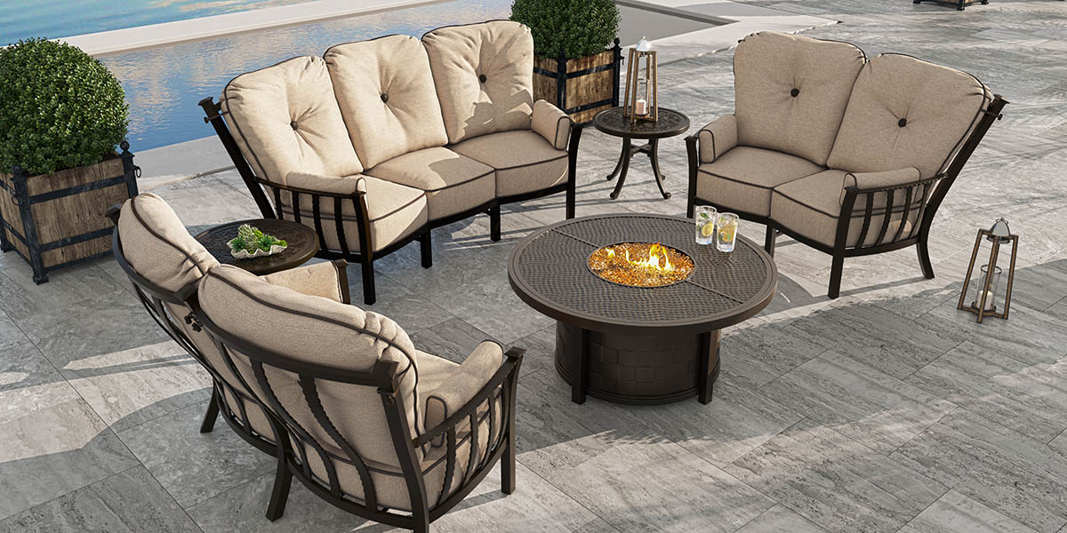
“Each season, we are proud of the original collections created by our design team,” said Mark Stephens, president, Castelle. “The SANTA FE collection is in keeping with this dedication to offering not only unique designs; but also, variety in looks to our retail partners and their consumers whatever their locale or style preferences.”

Inspired by southwestern artistry, the handcrafted cast and extruded aluminum of the SANTA FE collection from Castelle provides a unique décor for outdoor spaces. The hammered-look arms and the high cushion or sling back design creates overall alfresco appeal. Crescent deep seating in the SANTA FE collection delivers superior comfort and conversational lounging options. All pieces feature a durable multi-stage powder coat finishing and optional artisan applied antiquing.

For more information about Castelle and luxury casual furniture, visit www.castelleluxury.com.
# # #

High Resolution images available. Contact: lrudd@pridefamilybrands.com
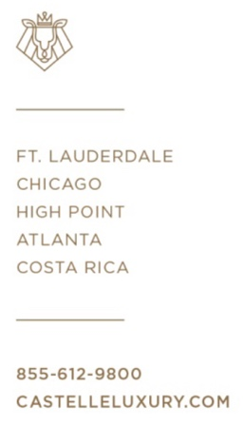
Pictured: Santa Fe Crescent Deep Seating

About CASTELLE®.
For over 40 years, CASTELLE has distinguished itself in the manufacturing of award-winning luxury casual furniture. Innovation, state of the art manufacturing, and superior quality products are the trademark of CASTELLE and the reason CASTELLE is recognized as a leader in the casual furniture industry. CASTELLE has been the recipient of multiple Manufacturing Leadership awards for the Cast Aluminum category.

