Tavolo Marco Polo - Midj
design Paolo Vernier

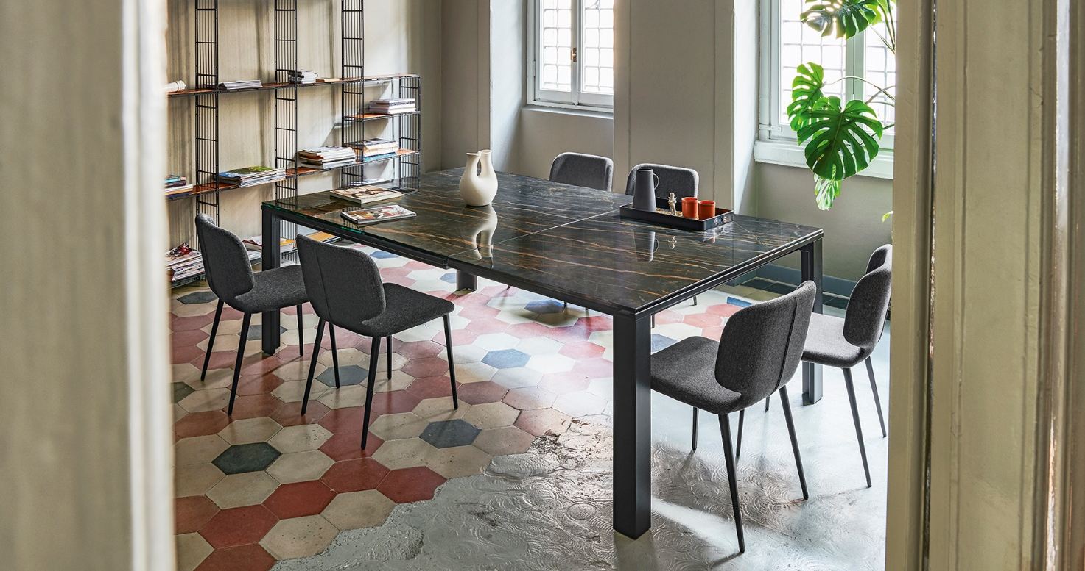

Already present in the particular extendable version of 140 x 140 cm, Midj Marco Polo Table is now renewed in a rectangular shape 160 X 100 cm to satisfy every furnishing need.
Ideal for the open spaces of the living area, the table is extendable thanks to a semiautomatic mechanism that facilitates its opening, to give space to elegance and comfort.
To characterize the furnishing complement: legs and structure in painted metal and the top in crystal-ceramic available in the new refined finishes ceramic-glass Veneziano and Noir Desir.
Marco Polo tabletop is also available in the ceramic-glass Calacatta Marble and Greek black Marble finishes.
www.midj.com/

Since 1987 Midj has cleverly combined design and the art of modeling the raw material with the creation of custom-made furniture and accessories, to emphasize modernity and elegance in every environment.
From chairs to coat hangers, from tables to armchairs, each product features a concentrate of Made in Italy mastery, which is characterized by a soft and refined design. Thus colorful and versatile ideas come to life, which easily adapt to public and private spaces, guaranteeing a delicate but at the same time hi-tech character.
From the development of the design of the model to the industrial print run, every phase of production is scrupulously followed by master craftsmen of iron, wood, leather and plastics, to combine craftsmanship, creativity and technology into furnishing elements aimed at the highest quality and resistance over time.
To support the philosophy of the Friulian brand, the Integrated Management System certified according to ISO 9001: 2015 and the ISO 14001: 2015 certification, for compliance with environmental regulations, reduction of consumption and pollution. The Code of Ethics is so important: promoting virtuous behavior and processes aimed at combining the correct conduct of the company with the expectations and interests of individual employees.

