Wexel Art Launches New Acrylic Sculpture Collection
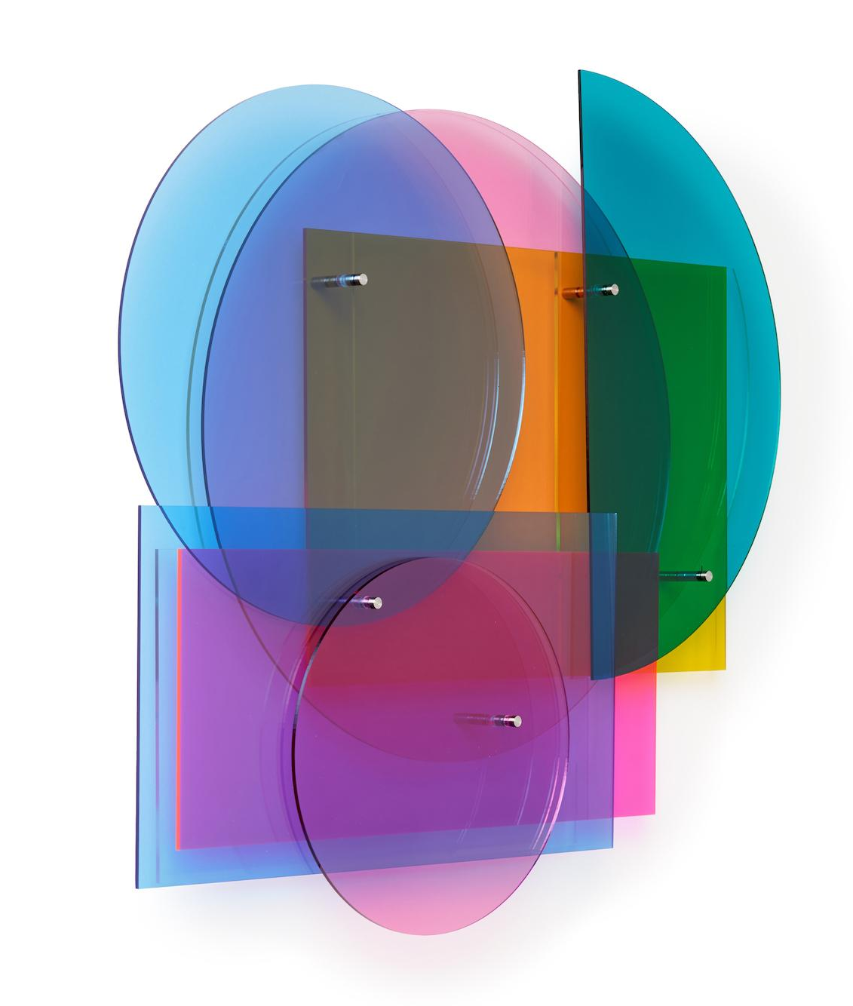
The partnership between Wexel Art and Melissa Borrell came together naturally since both are based in Austin, Texas and specialize in acrylic, and have a great passion for art. Using light, shadow and movement, Borrell creates artwork and spaces that encourage viewers to slow down, wonder and smile.

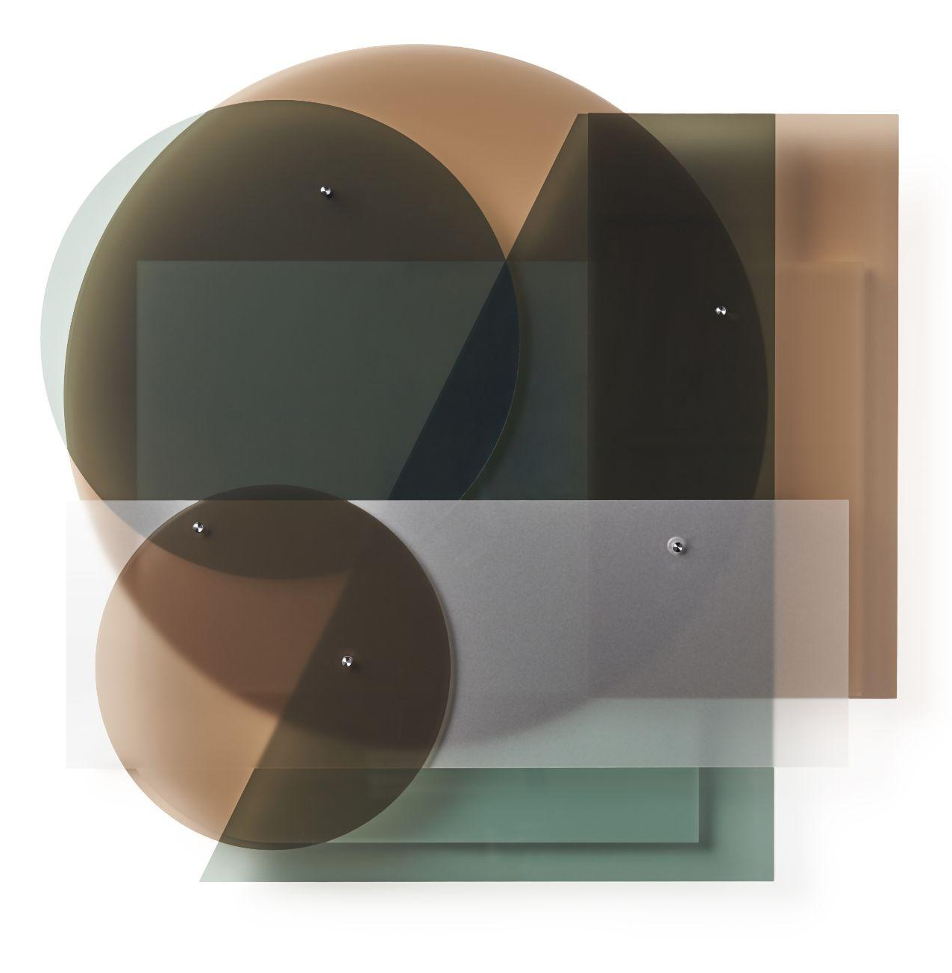
“In creating this series, I was thinking about sunrise, sunset and the sense of calm they bring. This work is about new beginnings, taking time to look at the beauty around us, and finding peace in the middle of chaos.” - Melissa Borrell

This collaboration has resulted in the launch of four acrylic sculptures with two color palettes. The Vibrant collection, Vibrant Sun and Vibrant Moon, features multiple layers of neon and electric acrylic colors, in various bold shapes that blend and create new pops of lively colors together to cast shadows and light, making it an eye-catching 3D art piece.

The Midnight collection, Midnight Sun and Midnight Moon, offers the same shapes and styling, but with a neutral palette for the modern art lover with a taste for all things monochromatic.

“The sculptures look stunning on their own, but are even more exciting when you stack, stagger, or rotate the acrylic masterpieces to unleash the inner artist within us all and create an installation that is unique to each individual,” said Morgan Doherty, co-Founder.

About Melissa Borrell
Austin-based artist Melissa Borrell creates kinetic, architectural sculptures and immersive environments that surprise and delight while striving to inspire participants to see the world in a new way. https://www.melissaborrell.com/
About Wexel Art
Wexel Art frames offer a contemporary way to showcase art, photos and keepsakes and the ability to change them easily and often, without the expense of traditional framing. Wexel Art was thoughtfully founded on the commitment that products should make showcasing life’s little pleasures such as photographs, kids’ paintings, and holiday cards in a clean, modern sustainable way.

