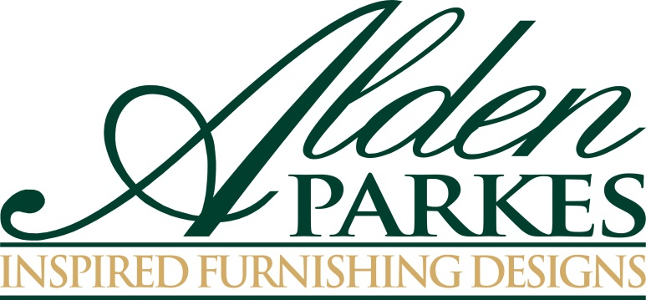

FOR IMMEDIATE RELEASE Media Contact:

Nicole Howley

336.884.5020

Nicole@gefenmarketing.com

ALDEN PARKES PUTS EMPHASIS ON STORAGE, ACCENT FURNITURE
Alden Parkes introduces storage and accent furniture that is as practical as it is beautiful

Jacksonville, FL—Jacksonville, Florida-based Alden Parkes is bringing an array of versatile new accent pieces to the Fall 2015 High Point Market with an emphasis on storage furniture that is as practical as it is beautiful. Known for its deft handling of natural materials and fine finishes, Alden Parkes mixes and matches wood, brass, glass, painted finishes, lacquer, applied leaf, and vellum for a range of elegantly simple designs.

Storage pieces being introduced at this Market include:

The 3-drawer Allegra Bedside Chest picks up the elegant motif from the popular Allegra Headboard and Allegra Mirror. This time, however, it is interpreted in solid brass hardware and framed in a solid brass accent border. The chest is available in Tiffany White or a natural Warm Walnut finish.

The Monaco 2-Door Cabinet is a chic, two-shelf, mid-Century Modern-inspired low cabinet in hand-rubbed walnut stain with solid brass accents. At 36” high and just 18” deep, the cabinet can work in virtually any room in the home.

The handsome Hampton Étagère combines closed storage with open glass display shelves supported by a graceful brushed brass frame. The cabinet, decorated with a eggshell inlay finish, is inset with finger-pull solid brass hardware on the two front doors.

The trim Vellum Box on Stand can be an end table or a stand-alone accent piece. The box, which sits on a sleek brass stand, has a drawer, which opens with its own solid brass key and is covered with distinctively patterned vellum. Legs and box together stand 24” high.

The Pinnacles Credenza is a flirty combination of Deco and Mid-Century Modern, and is a natural beauty in mid-toned eucalyptus veneer, set off with sculptural solid brass hardware. The credenza measures 72” long.

In addition to distinctive storage pieces, Alden Parkes is showing strong new designs in accent furniture. New pieces include:

A touch of flash: the oval Jolene Cocktail Table is finished in two tones of applied leaf—gold on the curved legs and intersecting arched stretchers, and burnished brass on the rim. The tempered glass tabletop is beveled and inset into the base for a flush top.

Sleek, sculptural and versatile, the Triangle Accent Table can stand alone or be bunched to create a cocktail table or low occasional table. A single component is 24” wide, 12” deep, and 18” high; the table is available in Tiffany White or Tiffany Black painted finishes or warm natural Rosewood in a hand-rubbed French finish.

The Pinnacles Arm Chair with its clean profile, natural wood frame and Euro Linen upholstery is the perfect foil for the modernist Pinnacles Dining Table. COM service is also available.

Please join us at 200 North Hamilton Street, Suite 207, during the Fall 2015 High Point Market to see all of Alden Parkes’ new product introductions. Lunch will be served daily.

###

About Alden Parkes:

Alden Parkes is a high-end furniture manufacturer based in Jacksonville, FL owned by entrepreneurial veterans Lynne and Khrys McArdle. Alden Parkes offers an extensive line of home furnishings: upholstery, occasional tables, dining, cabinetry, mirrors, accessories and lighting. Their commitment to quality begins with materials. Premium woods, from solid mahogany to weathered driftwood acacia, are masterfully carved by hand and paired with solid brass hardware. Finishes range from deep brilliant sheens to subdued, casual distressed applications.

Media Note: To download the images and information of product shown in this press release, please visit: http://bit.ly/1V60R11

