For immediate release
CASTELLE to Debut Latest Barclay Butera Outdoor Collection During April High Point Furniture Market
April 2, 2018 - Ft. Lauderdale, Fla.- The successful collaboration between award-winning, luxury outdoor furnishings manufacturer Castelle and renowned author and interior designer, Barclay Butera is set to expand with the unveiling of the Barclay Butera Palm Springs Collection for Castelle. During the April 2018 High Point Furniture Market, the artistry of Butera and Castelle will be on display once again with custom cast aluminum outdoor furnishings. The Palm Springs Collection will be presented for the first time in the Castelle High Point showroom at IHFC Main 101 during the international furniture market being held April 14 – 18, 2018.

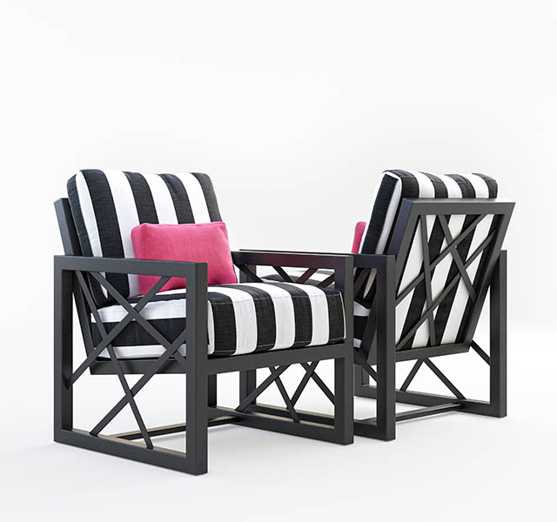
“With the tremendous success of Barclay’s Signature Collection, we are excited to introduce to market goers the new Palm Springs Collection,’ said Mark Stephens, president, Castelle. “This collection is true Barclay Butera with a nod to mid-century modern and old Hollywood; but with his designer aesthetic and dramatic color selection. We are confident this collection will be well received by design professionals and retailers throughout the market.”

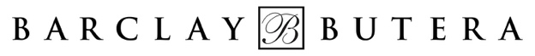
Since 2016, Castelle has collaborated with Butera on luxury outdoor collections with the Signature Collection introduced in 2017 producing the highest sales of any new introduction in the history of the company. The Barclay Butera Collection for Castelle is handcrafted to capture the modernism vibe found in Hollywood’s playground. The ongoing collaboration of Castelle’s skilled craftsmen and Barclay Butera’s touch of stardust results in a collection designed for ultimate relaxation. The Barclay Butera Palm Springs Collection incorporates intersecting and askew lines into a strong geometric frame. Butera’s vision for luxe leisure is on display at every angle of dining and deep seating pieces, tables and a fire pit. Custom fabrics and finishes create a designer statement that is fresh and modern.

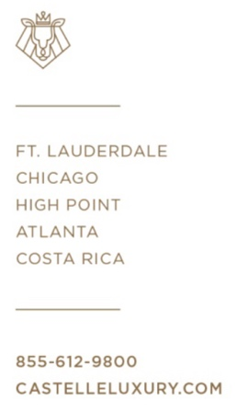
“I am so thrilled to launch my sleek and chic new Palm Springs collection which is a fresh modern departure from my original, classic Signature blue and white,” commented Barclay Butera. “Creating something that would resonate with buyers and clients looking for a transitional option for outdoor was our goal; the black white and pink makes it fun and cheeky! And of course, with Castelle’s incredible capabilities the color and pattern options for textiles are endless for a bespoke look.”

CASTELLE to Debut Latest Barclay Butera Outdoor Collection During April High Point Furniture Market
Page two

The debut of this new collection for Barclay Butera and Castelle will include a launch event, “Outdoor Living with Barclay Butera & Hearst Design Group in the Castelle Showroom at IHFC Main 101 from 5p – 7p on Saturday, April 14th. A panel Q & A will be conducted by Karen Marx of Hearst Design Group and Barclay Butera followed by cocktails and appetizers. The event is open to all market attendees.

From designing luxury residences, exclusive hospitality venues, to Rolls-Royce automobiles; Barclay brings his signature West Coast vibe and glamorous yet livable design sensibility to life for outdoor with this collaboration. Since 1994, he has been the creative force behind his eponymous design firm and showrooms located in Newport Beach, Corona Del Mar and West Hollywood, California as well as Park City, Utah. Butera is renowned for his welcoming elegance and glamorous, West-Coast-chic interiors. His interior and exterior design expertise allows Butera to understand the total home concept.

The introduction of the Barclay Butera Palm Springs Outdoor Collection for Castelle will continue during the ICFA (International Casual Furnishings Association) Preview Show in July 2018 and the ICFA Casual Market Chicago in September 2018.

For more information about Castelle and luxury casual furniture, visit www.castelleluxury.com.

# # #

High Resolution images available.
Contact: lrudd@pridefamilybrands.com

Pictured: Lounge Chairs from the Barclay Butera Palm Springs Outdoor Collection for Castelle

About CASTELLE®.
For over 40 years, CASTELLE has distinguished itself in the manufacturing of award-winning luxury casual furniture. Innovation, state of the art manufacturing, and superior quality products are the trademark of CASTELLE and the reason CASTELLE is recognized as a leader in the casual furniture industry. CASTELLE has been the recipient of multiple Manufacturing Leadership awards for the Cast Aluminum category.

