Designer Dann Foley to Headline Loloi Market Event, April 7

Attendees have chance to win a weekend getaway for two to Palm Springs

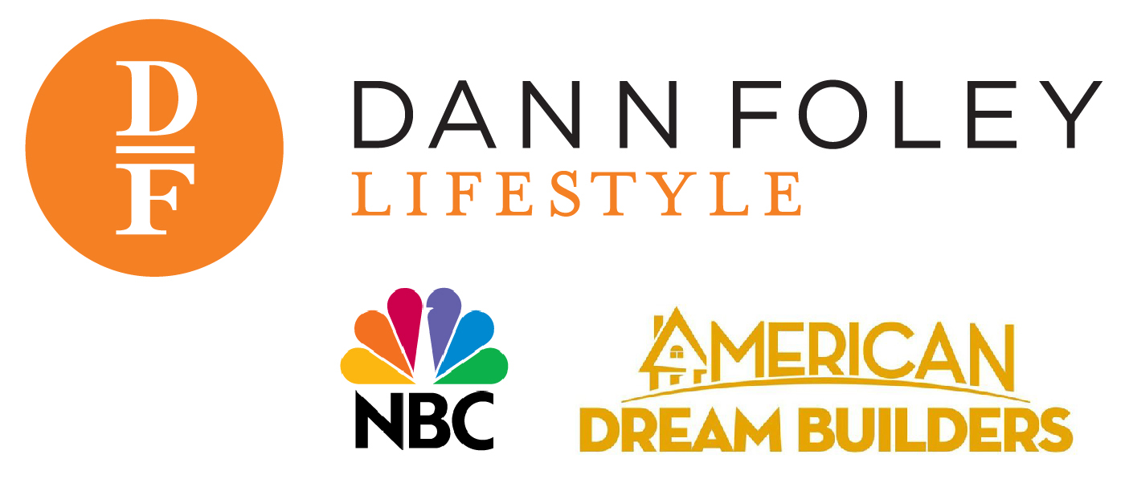
DALLAS (March 20, 2014) ― Loloi announces it is hosting a meet-and-greet event with interior designer and TV personality Dann Foley during the April High Point Market. Fresh off the set of NBC’s American Dream Builders reality show, Foley will headline a meet-and-greet in Loloi’s showroom, IHFC D320, on Monday, April 7 from 5-6:30 p.m., immediately following his presentation in Market Square. As a tribute to Foley’s new Palm Springs Collection for Loloi, all attendees of the event will have a chance to win a weekend getaway to Palm Springs, Calif.

The winner, who will be selected by a random drawing, will receive a trip for two to the California resort town and a weekend stay at the Korakia Pensione—named one of the “Sexiest Hotels in America” by Forbes Traveler. To be entered to win, Market-goers can simply stop by Loloi’s showroom during Foley’s meet-and-greet and stay for a tropical cocktail and some spirited conversation.

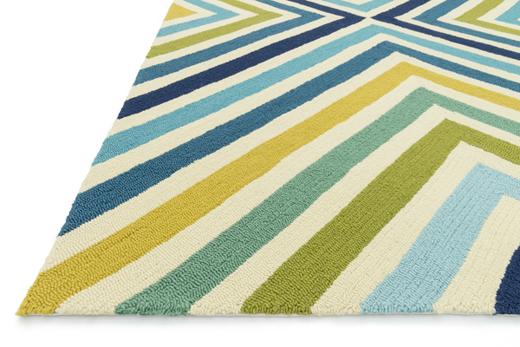
“This event is an opportunity for customers and designers to meet the persona behind the new Palm Springs collection, and to learn more about Dann’s inspirations behind his work,” said Amir Loloi, CEO. “Dann is a prolific designer who has been able to capture a fun and vibrant look and feel through the Palm Springs Collection, which was inspired by his upbringing in that city. With his newest success now about to launch on NBC-TV, we’re excited to have him spend some personal time at Loloi.”

Foley’s Palm Springs Collection includes patterns inspired by bold colors and patterns, and also dramatic wood flooring. Hand hooked in China of 100 percent polypropylene, Palm Springs is specially treated to be fade-resistant in spite of regular sunshine or rain.

To RSVP to this event, email CLoloi@loloirugs.com. For news, decorating guidelines and other updates from Loloi, connect via Facebook (www.facebook.com/loloirugs), Pinterest (www.pinterest.com/loloirugs), or the company website, www.LoloiRugs.com.

About LOLOI RUGS

Founded in 2004, LOLOI has become a fashion leader specializing in medium- to high-end area rugs in every style category, and a premium producer of textiles. Under the expert direction of area rug veteran Amir Loloi, the company has won two consecutive ARTS Awards for “Best Rug Manufacturer” in 2010 and 2011, one in 2012 for "Best Outdoor Manufacturer," and one in 2013 for “Green Manufacturer.” Its eight America’s Magnificent Carpets Awards and three Atlanta Visual Display Awards for sophisticated showroom design attest to the company’s commitment to innovation and quality.

LOLOI RUGS is headquartered in Dallas, with to-the-trade showrooms at: 295 Fifth Ave., New York, Showroom #1006 ● DallasMarketCenter, Suite #500 ● Las Vegas Market, Building B, Suite #480 ● High Point, IHFC Showroom #D-320 ● and AmericasMart, Atlanta, Showroom #4-D-2. For more information, visit: www.loloirugs.com. Call: (866) 362-1424.

