Contact Ashley Barton  Telephone 336.838.5178  Cell 804.931.8171  Email press@johnstoncasuals.com  Website www.johnstoncasuals.com | FOR IMMEDIATE RELEASE  April 11, 2017
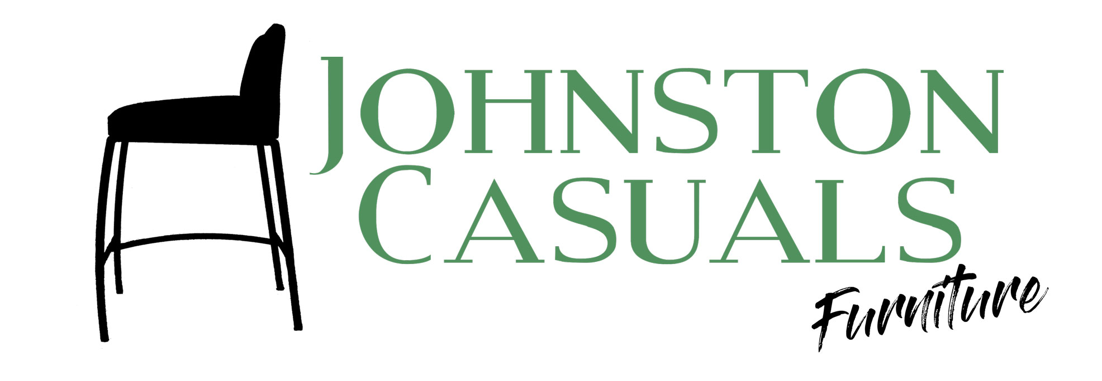

Several Johnston Casuals Introductions at High Point Spring Market Ahead

North Wilkesboro, NC, March 30, 2017– Johnston Casuals is proud to announce the addition of several new designs to the Johnston Casuals line. New introductions include designs from John LeShane, Broussard Walker, and Michael Wolk.
At the 220 Elm showroom in High Point, Johnston Casuals will show new dining tables, dining chairs, barstools, bench seating and occasional tables. In addition to their new designs, Johnston Casuals will also be unveiling a new premium finish that can be applied to many of their new and existing products.
Johnston Casuals Furniture manufactures contemporary furniture using 97% recycled Southeastern USA steel in their factory in North Wilkesboro, NC. Now in our 36th year, we pride ourselves on providing design products to our customers at competitive market prices. Our design showroom is located at 220 Elm, Level 3, Space 306. Please contact Ashley at press@johnstoncasuals.com for more information.
# # # #
If you would like more information about Johnston Casuals, please contact Ashley Barton at 336.838.5178 or email at press@johnstoncasuals.com. Please see enclosed images of new introductions along with their bulleted designers.

