EXPERIENCE THE ELEGANCE OF OLD TOWN BLUFFTON INN DURING SPRING MARKET
French Heritage Evokes the Southern Charms of New Boutique Inn in its Showroom

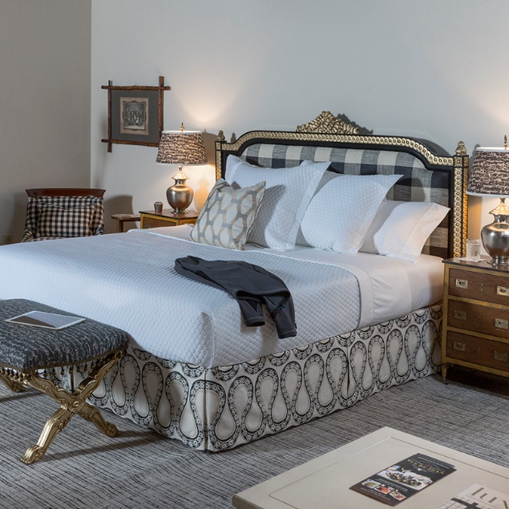
HIGH POINT, N.C., March 22, 2018 – In its corporate showroom on English Road, French Heritage has recreated the elegance and luxurious charm of the Old Town Bluffton Inn — scheduled to open this July — with its French Country and Colonial inspired furniture and accessories pieces.

At High Point Market in April, French Heritage showroom guests and visitors will get an exclusive look of six of the 14 rooms of the Old Town Bluffton Inn. As with the soon-to-be-open boutique inn, each room reflects the stately and traditional feel the owner and builder, Larry Leary wanted, combined with the fashion and flair that Danielle Harrison, the owner’s daughter sought to achieve. Utilizing a variety of colors, patterns and custom pieces, each room is also designed and furnished to embody its own unique theme and personality.

“This was such a fun and amazing project, and we’re so exciting to be part of Larry’s vision and dream come true.” said Henessy Wayser, President of French Heritage. “The best part was understanding and helping Larry achieve the feelings and emotions he wanted his guests to experience while at the Inn.”
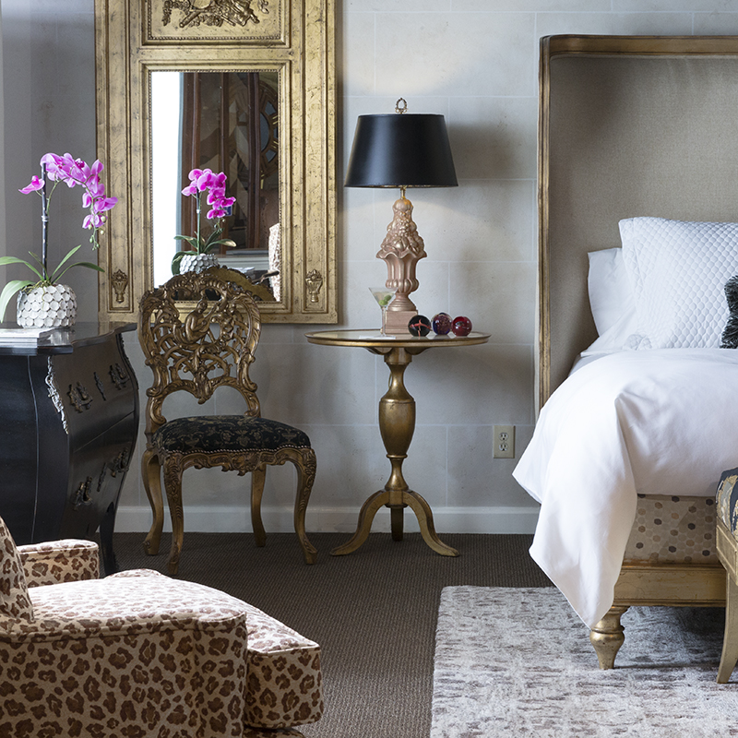
High Point Market attendees are invited to stop by the French Heritage showroom for a sneak peak of Old Town Bluffton Inn. While there, they can also register to win a weekend for two this summer.
Furniture Market press and attendees are invited to attend the Bluffton Inn Southern Hospitality Event for signature Bluffton Inn cocktails and delicious Southern American classics, prepared by Blake Elsinghorst — Le Cordon Bleu chef and Savanna, GA restaurant owner — from 5 p.m. to 8 p.m. on Sunday, April 15th. Event attendees can also meet Inn owners, Larry who is also the builder, and his daughter and husband, Danielle and Vince.

About FH Contract
FH Contract, a division of French Heritage, is a leading manufacturer that specializes in custom contract furniture for the luxury hotel industry and upscale residential homes. From casegoods to millwork, and traditional to contemporary, every piece of furniture is custom made to achieve the highest level of quality in design, construction, finish, and delivery to meet and exceed all expectations. FH Contract’s worldwide manufacturing partners allow the company to offer the best solution for each unique project.
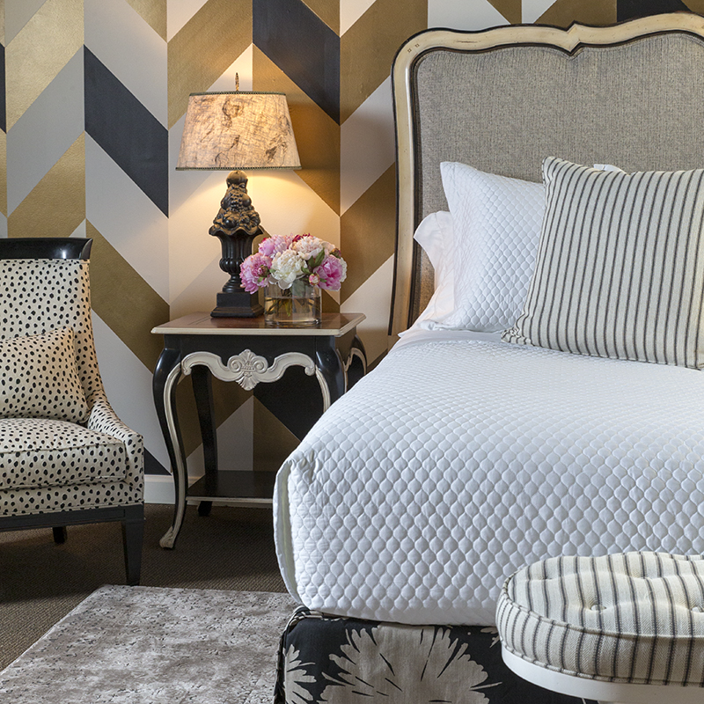
About French Heritage
French Heritage, Inc. is a fashion-forward furniture manufacturing company that excels in quality home furnishings. Using premium materials and European master craftsman techniques, the company combines contemporary elegance and eclectic flair for today's lifestyle. A founding member of the Sustainability Furniture Council, French Heritage is committed to ethical business practices and promoting furniture manufactured in an environmentally and socially responsible way. French Heritage is sold through fine furniture retailers, interior designers, and select high-end luxury lifestyle websites.

For more information about French Heritage, visit frenchheritage.com, and follow the company on Facebook, Instagram, Pinterest, Houzz, Twitter, YouTube, and LinkedIn.

###

For media inquiries, contact:
Henessy Wayser
President
HenessyDirect@frenchheritage.com
P: 336.882.3565

Lisa Thornton
Lisa@frenchheritage.com
P: 336.882.3565

