“DALÍ, sophisticated high-end Executive office furniture by HURTADO”
September 15 / 2014

HURTADO furniture is created by using highest quality woods and finest veneers by the most skilled team of craftsmen in Spain. Hand carvings, exquisite inlays, distinctive marquetry and superb finishes enhance the inherent beauty of natural wood.

At HURTADO’s factory in Valencia, Spain, each piece of furniture is produced according to traditional hand-crafting techniques, as well as using the most advanced technology in systems of production and quality control.

In both lines, TRADITIONAL and EVOLUTION, each collection has its own personality and features a unique styling statement bringing out authentic masterpieces that are classic in spirit but offer modern functionality.
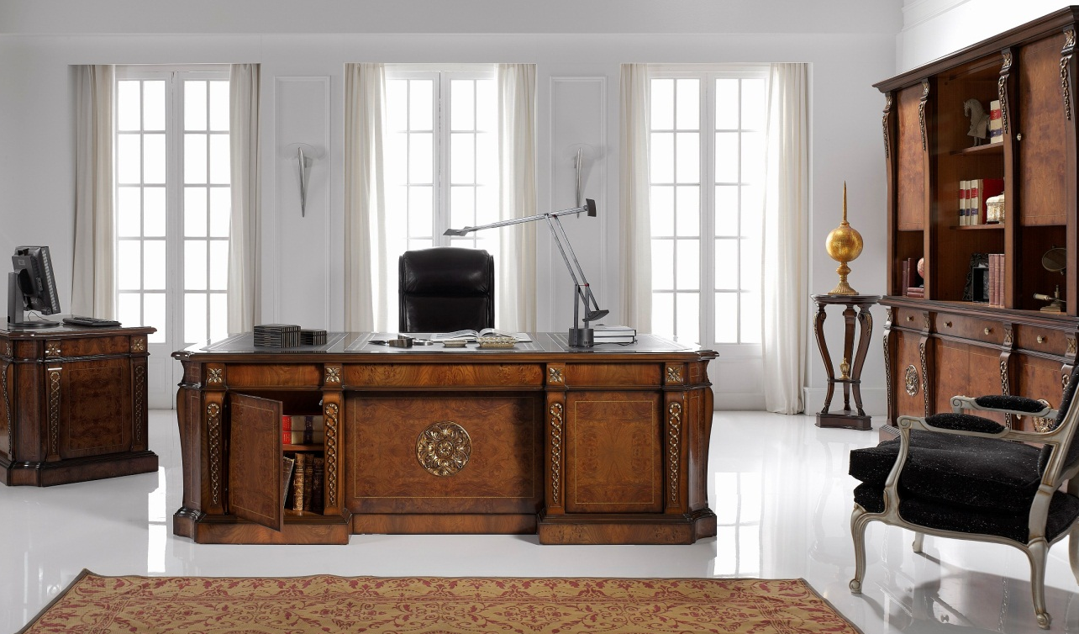
DALÍ collection, executive desk in elm, TRADITIONAL line
The new DALÍ collection updates HURTADO’s office furniture proposal with sophisticated and highly elegant designs that includes bookcase, computer desk, executive desk and credenza in different finishes of elm and walnut veneers including hand applied gold leaf details for complete Executive office decoration.

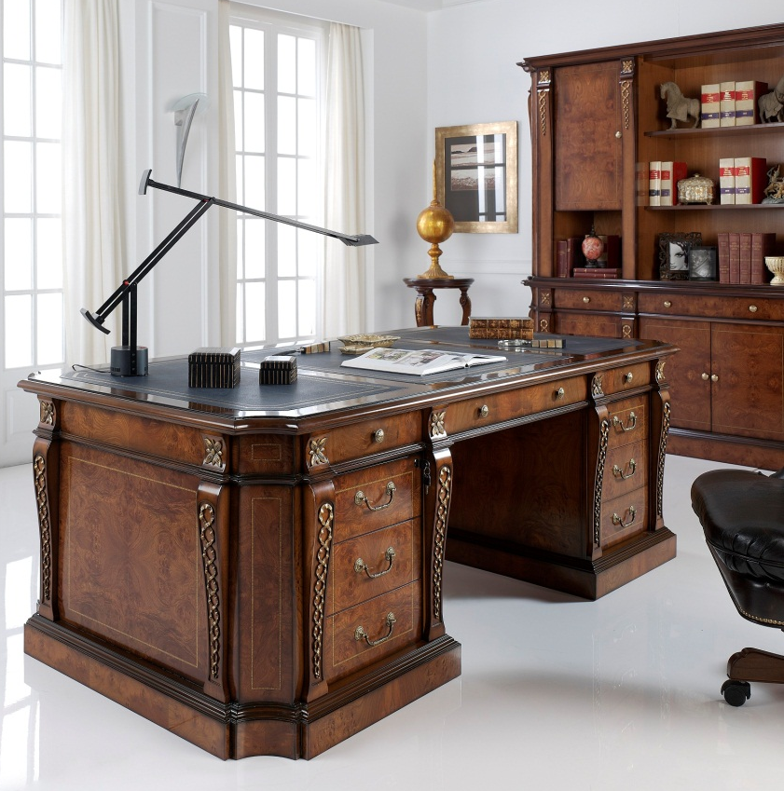
DALÍ collection, details executive desk in elm, TRADITIONAL line
Following HURTADO’s strong commitment to extraordinary quality and continuous design updating, DALÍ office furniture collection is the perfect choice for public and private Executive offices. Nevertheless, DALÍ allows versatility in dimensions, finishes, marquetry and inlays, adapting to the spirit of each project and always looking for complete customization.
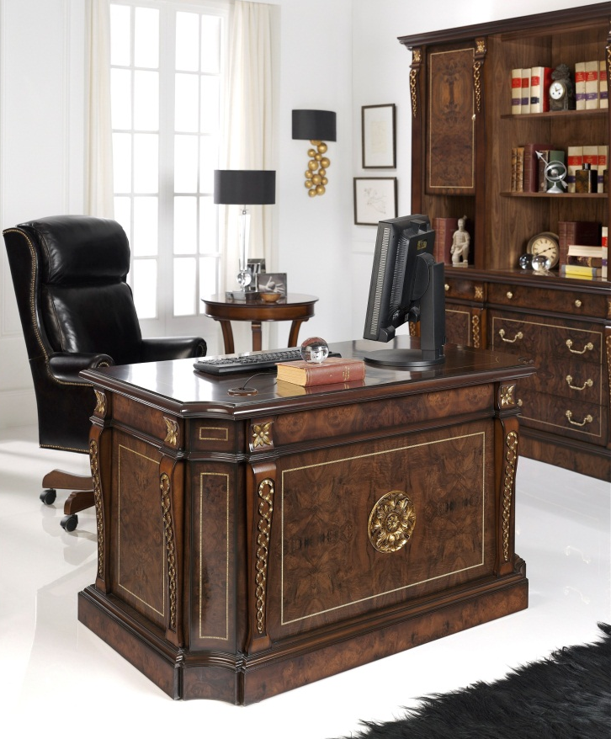
DALÍ collection, computer desk and bookcase in walnut, TRADITIONAL line
Veneers are made from different European and American woods, such as walnut and elm, and are assembled emphasizing the handcrafted processes while enhancing the natural beauty of materials as a tribute to Spanish handcrafting tradition.
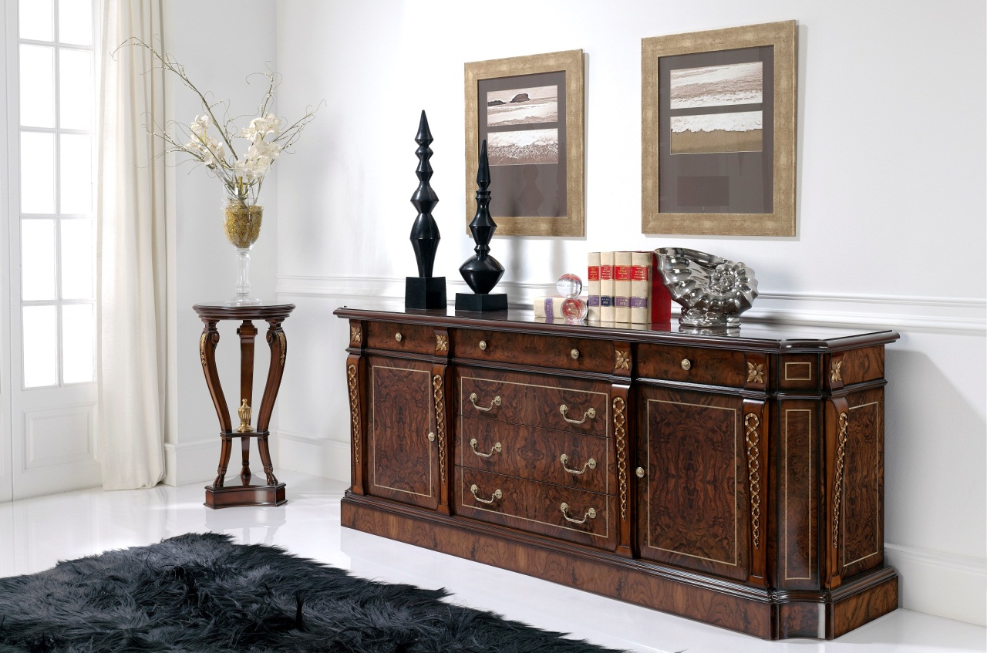
DALÍ collection, credenza in walnut, TRADITIONAL line
Spanish classical high-end furniture is in high demand in the contract sector, where it is appreciated for its brilliant design and excellent finishes. No wonder that HURTADO, one of the world’s most renowned brands of the Spanish furnishing industry, was chosen by the Saudi Arabian Ministry of Interior to furnish its main offices in Riyadh. The firm is actually working in the refurbishment of the astonishing Negeri Sembilan Palace in Malasya.
Specialized in the production of home-office furniture, dining - and bedrooms, and occasional pieces, HURTADO has strived to keep up with the newest trends while maintaining its excellence and handcrafts tradition. From high-end executive offices in classical style to art-deco home furniture solutions, HURTADO dazzles in foreign markets with exquisite contemporary personality.
More information: www.hurtadofurniture.com

