FOR IMMEDIATE RELEASE:

Wexel Art Displays
High Point Market Showplace #2335
Brynne Wong
877-609-1920x3
brynne@wexelart.com

Tabletop Frames – Best Accessory Finalist

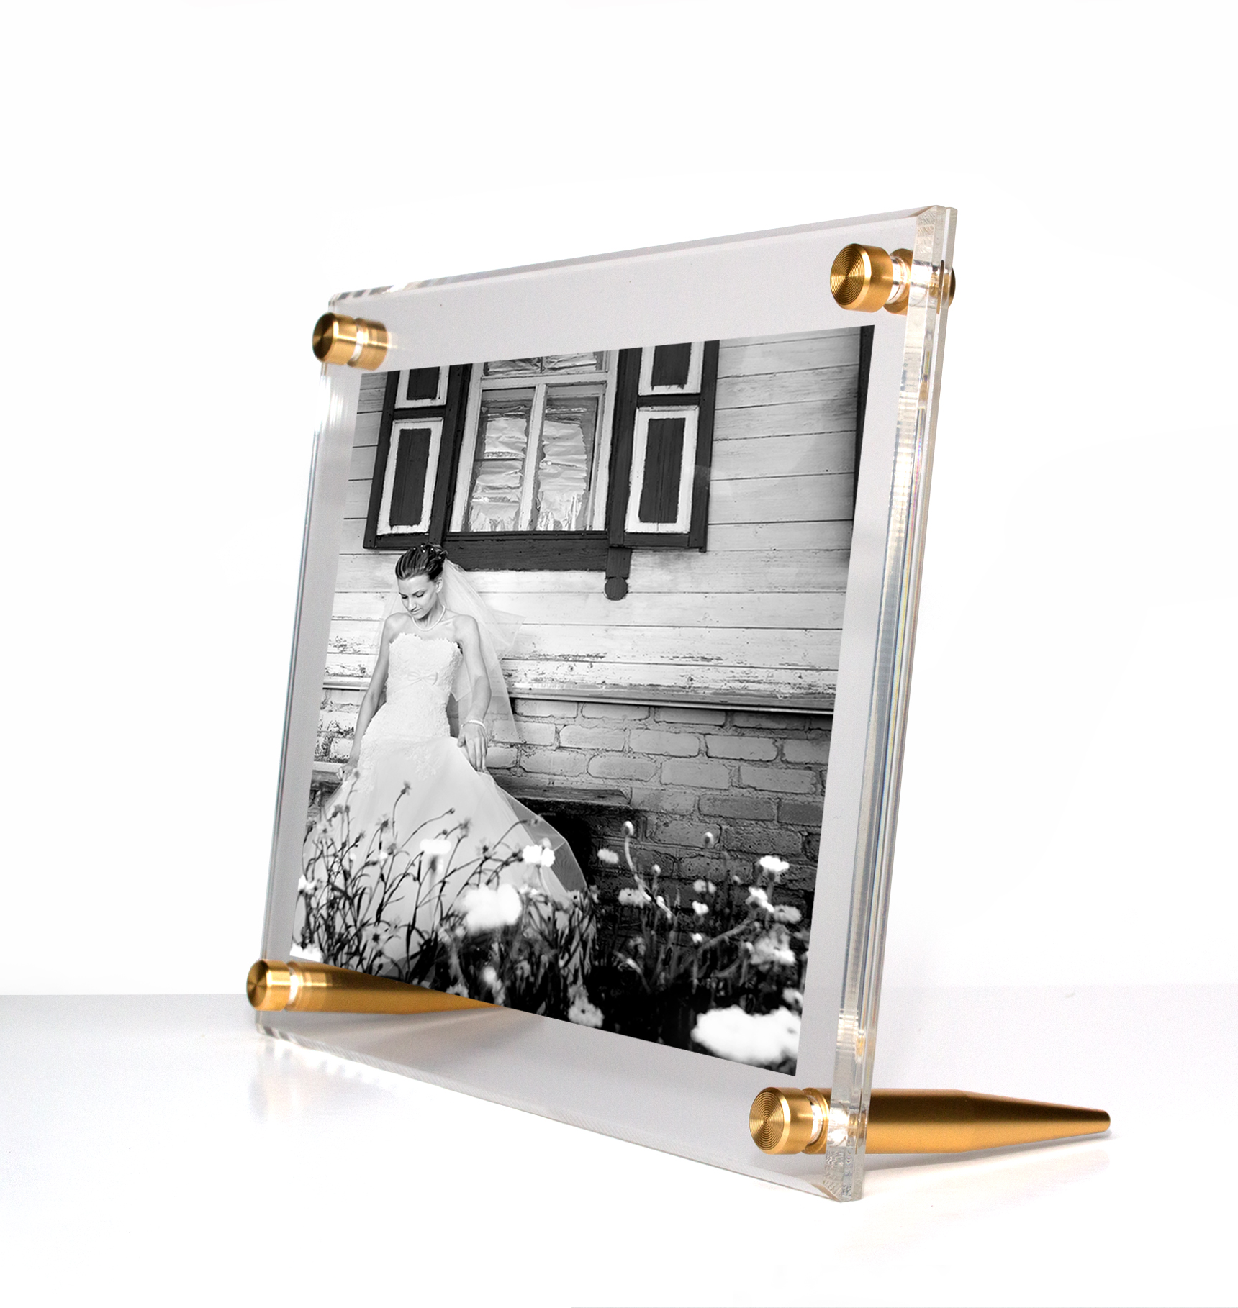
New York, NY – August 8, 2018 – Wexel Art is thrilled to announce that the 5x7” Tabletop frame with gold hardware has made it to the final round for the Best Accessories in the Pinnacle Awards. In the short time it has been on the market, this Tabletop frame has quickly become one of Wexel Art’s best sellers*.
These clear, diamond-polished acrylic frames are perfect for displaying family photos, postcards, graduation announcements, wedding invitations and more. The clever beveled edge detail catches the light in stunning ways. In addition to displaying family photos, Wexel Art’s tabletop frame also appeals to event planners, restaurants, and businesses as a creative way to display a menu or signage.
Each frame includes two high-design metal stands and two matching fasteners in either gold or silver. Interchangeable design enables for either portrait or landscape orientation. Simply unscrew to take apart and switch your favorite photo or memento.
During High Point Market, Wexel Art will also be offering a sneak peek of their newest Tabletop frames. Come by Showplace #2335 to get a first look at the brand new 4x6 Tabletop frame along with two new colors for Fall: rose gold and graphite.

About Wexel Art
Wexel Art frames offer a contemporary way to showcase art, photos and keepsakes and the ability to change them easily and often, without the expense of traditional framing. Wexel Art was thoughtfully founded on the commitment that products should make showcasing life’s little pleasures such as photographs, kids paintings, and holiday cards in a clean, modern sustainable way. For more information, visit www.wexelart.com.

Facebook | Instagram | Twitter | Pinterest
@wexelart
-end-

*Judging will take place by the Media & Industry members. Winners will be announced on Monday, October 15th.

